**Python Programming Exercises**:

This assignment involves writing several **Python script programs.**

1. Write a Python script that will input a name and two numbers. Your program should then output as follows:

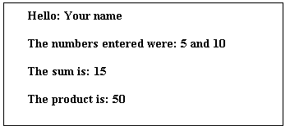

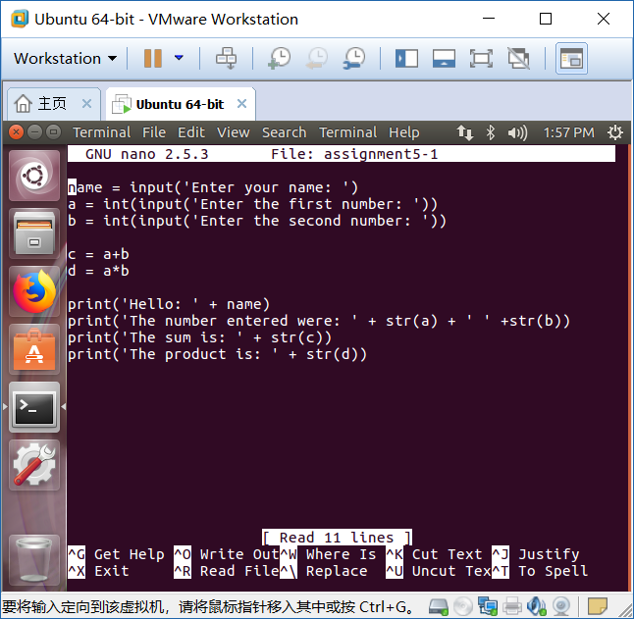

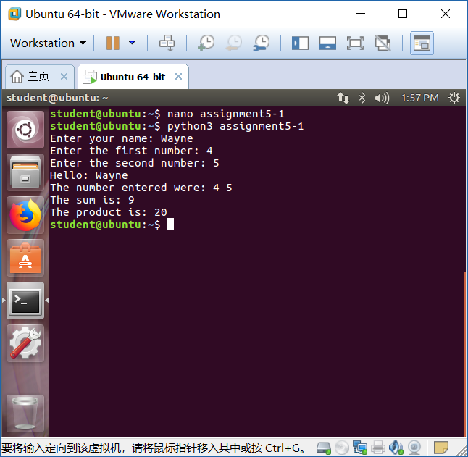

1. Rewrite the above program so your program will continue to execute.

Use break to exit the program.

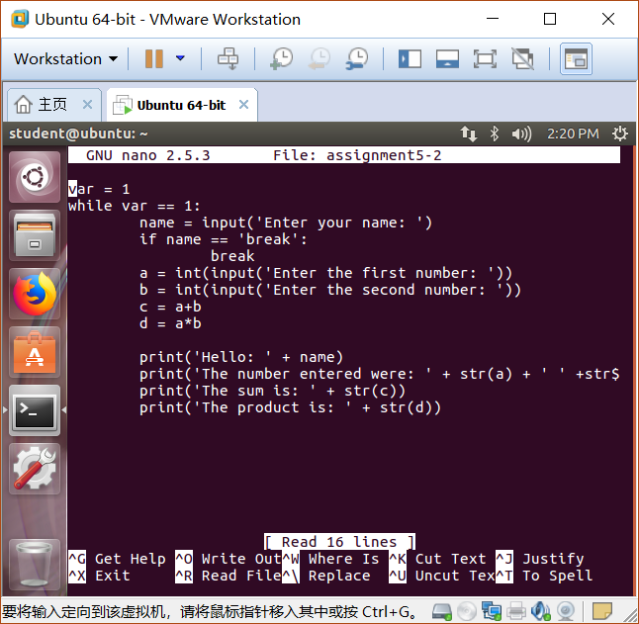

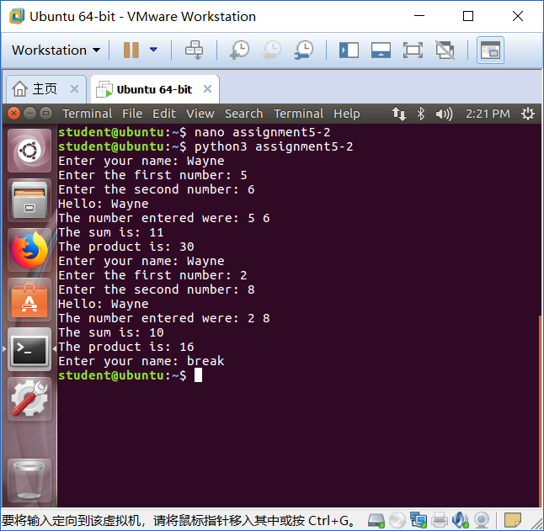

1. Write a Python program that will input a name and a numeric value between 0 and 100. For each name and number input you program should display the name, grades and letter grade.

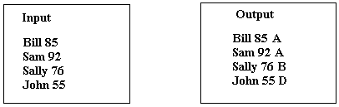

80 - 100 receives an A 70 -79 receive a B

60 – 69 receive a C 50 – 59 receive a D

